*Q-1 What is SDLC*

*A-1 A software development life cycle is essentially a series of steps or phase that provide model for the development and life cycle management of an app or price of software*

*Q-2 What is Software Testing?*

*A-2 Software testing is a process used to identify to the correctness completeness and quality of developed computer software*

*Q-3 What is Agile Methodology?*

*A-3 Agile SDLC model is a combination of iterative and incremental process models with focus on process adaptability and customer satisfaction by rapid delivery of working software product*

*Q-4 What IS SRS.*

*A-4 A software requirements specification is a complete description of the behaviour of the system to be developed. Use cases are also known as functional requirements. In addition to use cases the SRS also contains non functional requirements.*

*Q-5 What is oops.*

*A-5 identifying objects and assigning responsibilities to these objects. Objects and message are received by the methods of an objects.*

*Q-6 Write Basic Concepts Of oops.*

*A-6 1. Objects 2.class 3.encapsultion 4.inheritance 5.polymorphism 6.abstraction*

*Q-7 What is Object.*

*A-7 This is the basic unit of object oriented programming. That is both data and function that operate on data are bundled as a unit called as object.*

*Q-8 What is Class.*

*A-8 A class represents an abstraction of the object and abstract the properties and behaviour of that object.*

*Q-9 What is Encapsulation.*

*A-9 Encapsulation is the practice of including in an objects everything it needs hidden from other objects. The internal state is usually not accessible by other objects.*

*Q-10 What Is inheritance.*

*A-10 Inheritance means that one class inherits the characteristics of another class. This is also called a is a relationship.*

*Q-11 What is polymorphism.*

*A-11 Polly refers to many. That is a single function or an operator functioning in many ways different upon the usage is called polymorphism.*

*Q-14 Write SDLC Phases With Basic Introduction.*

*A-14 1. Gathering 2. Analysis 3. Design 4. Implementation 5. Testing 6. Maintenance*

*Q-15 Explain Phases Of The Waterfall Model.*

1. *Requirements. Potential requirements, deadlines and guidelines for the project are analyzed and placed into a formal requirements document, also called a*[*functional specification*](https://www.techtarget.com/searchsoftwarequality/definition/functional-specification)*. This stage of development defines and plans the project without mentioning specific processes.*
2. *Analysis. The system specifications are analyzed to generate product models and*[*business logic*](https://www.techtarget.com/whatis/definition/business-logic)*to guide production. This is also when financial and technical resources are audited for feasibility.*
3. *Design. A design specification document is created to outline technical design requirements, such as the programming language,*[*hardware*](https://www.techtarget.com/searchnetworking/definition/hardware)*, data sources, architecture and services.*
4. *Coding and implementation. The*[*source code*](https://www.techtarget.com/searchapparchitecture/definition/source-code)*is developed using the models, logic and requirement specifications designated in the prior phases. Typically, the system is coded in smaller components, or units, before being put together.*
5. *Testing. This is when*[*quality assurance*](https://www.techtarget.com/searchsoftwarequality/definition/quality-assurance)*,*[*unit*](https://www.techtarget.com/searchsoftwarequality/definition/unit-testing)*,*[*system*](https://www.techtarget.com/searchsoftwarequality/definition/system-testing)*and*[*beta*](https://www.techtarget.com/whatis/definition/beta-test)*tests identify issues that must be resolved. This may cause a forced repeat of the coding stage for*[*debugging*](https://www.techtarget.com/searchsoftwarequality/definition/debugging)*. If the system passes integration and testing, the waterfall continues forward.*
6. *to a live environment.*
7. *Maintenance. Corrective, adaptive and perfective maintenance is carried out indefinitely to improve, update and enhance the product and its functionality. This could include releasing*[*patch*](https://www.techtarget.com/searchenterprisedesktop/definition/patch)*updates and new versions.*

*Q-17 Write Agile Manifesto Principles.*

*A-17 1- Customers Satisfaction through early and continuous software delivery*

*2- Accommodate changing requirements throughout the development process*

*3- Frequent delivery of working software*

*4- Collaboration between the business stakeholders and developers throughout the project*

*5- Enable face to face interactions*

*6-Working software is the primary measure of progress*

*7- Agile processes to support a Consistent development pace*

*8- Attention to technical detail and design enhances agility*

*9- Simplicity*

*10- Self-organizing teams encourage great architectures requirement and designs*

*11- Regular reflections on how to become more effective*

*Q-18 Explain working Methodology of agile model and also write pros and cons*

*A-18 Every iteration involves cross functional teams working simultaneously on various areas like planning, requirements, analysis, design, coding, unit testing, and acceptance testing.*

* *Pros- 1- Is a very realistic approach to software development*

*2- promotes teamwork and cross training*

*3- Resource requirements are minimum*

*4- Suitable for fixed or changing requirements*

*5- Delivers early partial working solutions*

*6- Good model for environments that change steadily*

*7- Little or no planning required*

*8- Easy to manage*

*9- Give flexibility to developers*

* *Cons- 1- Not suitable for handling complex dependencies*

*2- More risk of sustainability, maintainability and extensibility*

*3- An overall plan an agile leader and agile pm practice is a must without which it will not work*

*4- There is very high individual dependency since there is minimum documentation generated*

*5- Depends heavily on customer interaction so if customer is not clear, team can be driven in the wrong direction*

*6- Transfer of technology to new team members may be quite challenging due to lack of documentation*

*Q-16 Write agile Manifesto principles*

*A-16 1- Individual & nitration*

*2- Customer collaboration*

*3- working model*

*4- Responding to change*

Q- Draw use case on online book shopping

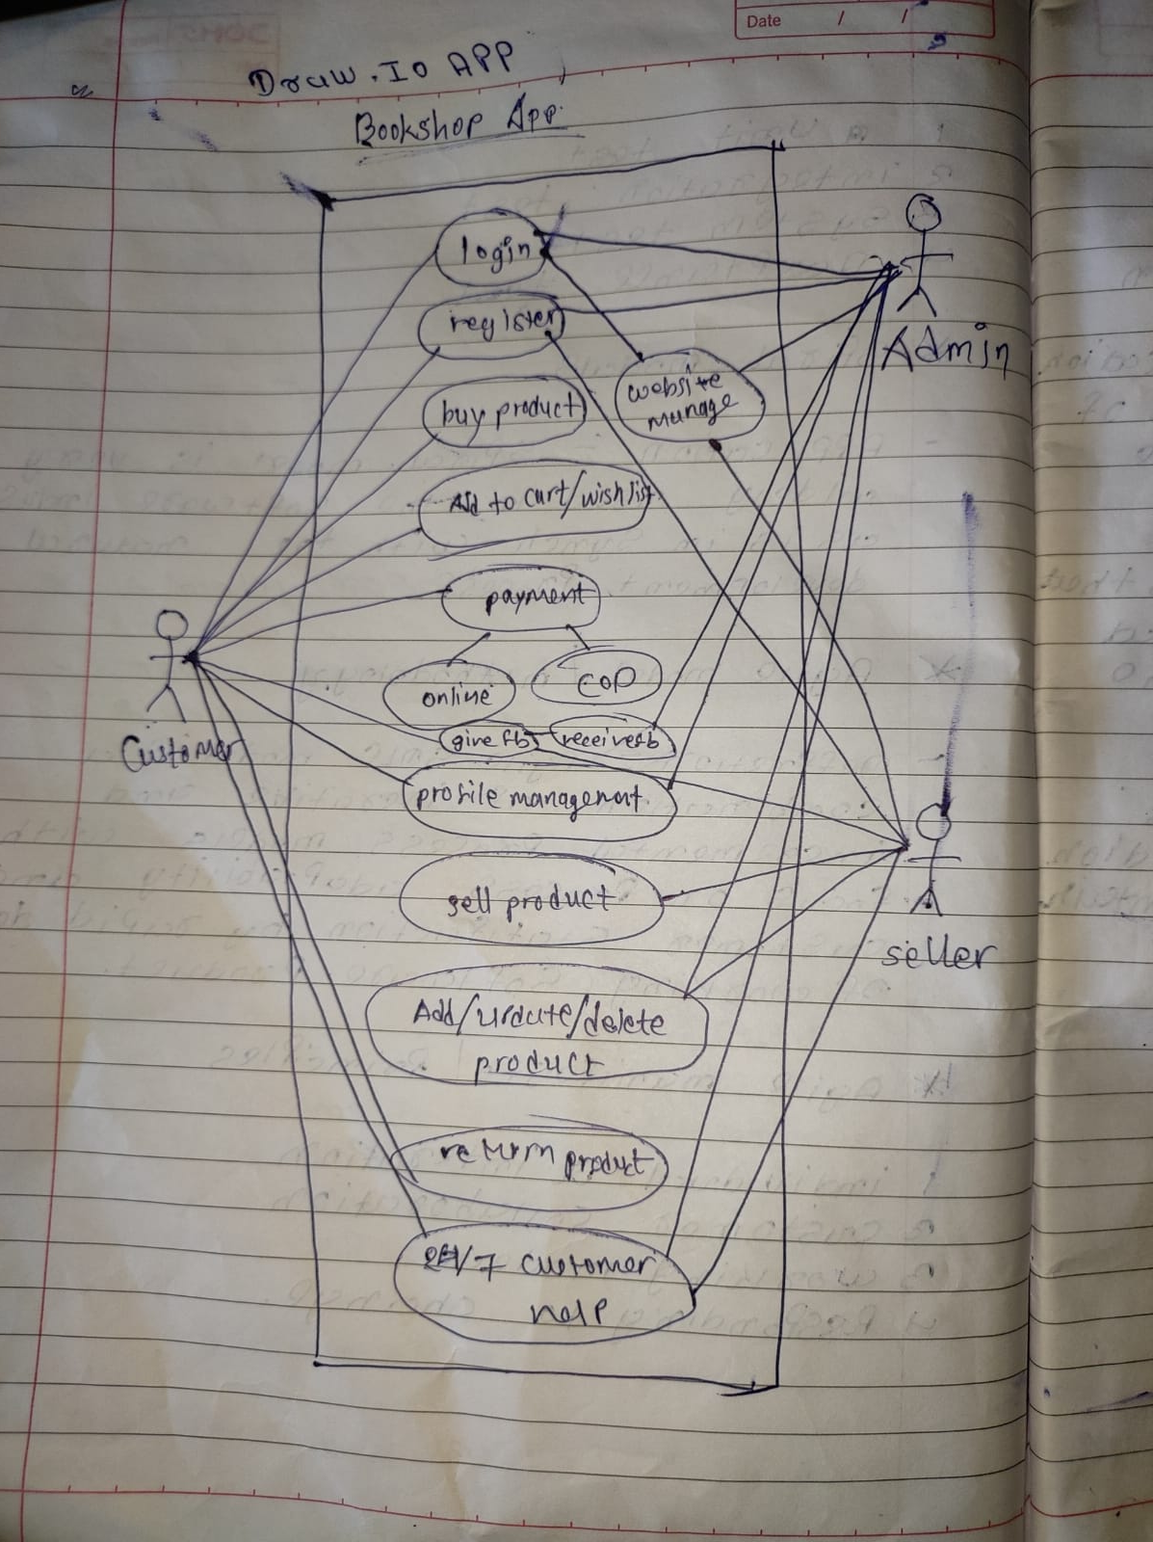

Q- Bill payment

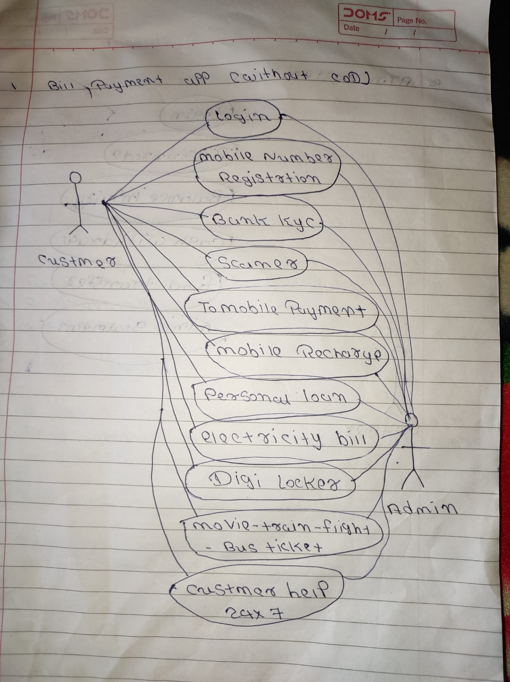

Q- online shopping using cod

